**ADVANCED DBMS LAB**

**EXPERIMENT NO. 3**

**Name: UPAS NATH**

**Roll No:47**

**Batch:B**

**Date:08/04/2022**

**AIM**

To familiarize DDL Commands-

ALTER, DROP, TRUNCATE, RENAME

**Questions**

1. Create a table emp with attributes empno number(4)as primary key, ename char(10),hiredate,  salary, commission

insert 5 rows of data

|  |  |  |  |  |
| --- | --- | --- | --- | --- |
| 101 | Ramesh | 17-Jan  1980 | 5000 |  |
| 102 | Ajay | 05-Jul  1985 | 5000 | 500 |
| 103 | Ravi | 12-Aug  1981 | 1500 |  |
| 104 | Nikesh | 03-Mar  1983 | 3000 | 700 |
| 105 | Ravi | 05-jul  1985 | 3000 |  |

CREATE TABLE EMP (EMPNO INT (4) PRIMARY KEY, ENAME CHAR (10), HIREDATE DATE, SALARY INT (5), COMMISION INT (5));

INSERT INTO EMP (EMPNO, ENAME, HIREDATE, SALARY, COMMISION) VALUES(101,'RAMESH','1980-01-17',5000,500), (102,'AJAY','1985-07-05',5000,500), (103,'RAVI','1981-08-12',1500,150), (104,'Nikesh','1983-03-03',3000,300), (105,'Ravi','1985-07-05',3000,300);

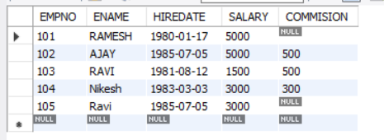

2. Modifying the structure of tables

a. Add new columns: sal number(7,2)

b. Dropping a column from a table: sal

c. Modifying existing column : ename varchar2(15)

d. Renaming the tables: emp to emp1

e. Truncating the tables: emp1

f. Destroying tables: emp

1. ALTER TABLE EMP ADD SAL INT;
2. ALTER TABLE EMP DROP COLUMN SAL;
3. ALTER TABLE EMP MODIFY ename VARCHAR(15);

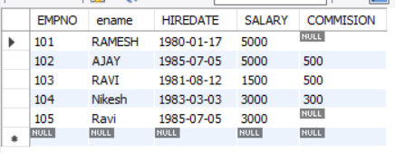

1. RENAME TABLE EMP to EMP1;
2. TRUNCATE TABLE EMP1;
3. DROP TABLE EMP1;
4. Create a table stud with sname varchar2(20) primary key , rollno number(10) not null,dob  date not null

CREATE TABLE STUD(SNAME VARCHAR(20) PRIMARY KEY, ROLLNO INT NOT NULL, DOB DATE NOT NULL);

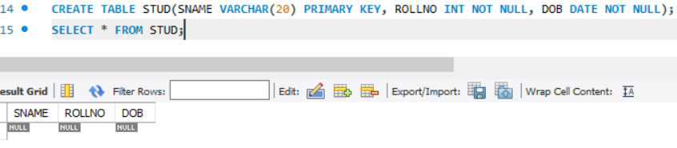

1. Create a table student as regno number (6), mark number (3) check constraint (mark >=0 and  mark  <=100));

In table student add check constraint(length(regno<=4))

CREATE TABLE STUDENT (REGNO INT, MARK INT(3) CONSTRAINT B CHECK (MARK >=0 AND MARK <=100));

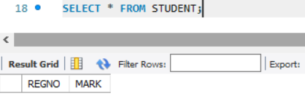

ALTER TABLE STUDENT ADD CONSTRAINT B2 CHECK (length(REGNO<=4));

1. Create a table cust with(custid number(6) constraint unique, name char(10)

CREATE TABLE CUST(CUSTID INT(6) NOT NULL UNIQUE, NAME CHAR(10));